In Vehicle Coupon Recommendation

TABLE OF CONTENTS:
- INTRODUCTION ………………………………………………………………………………………3
- PROJECT OVERVIEW ……………………………………………………………………………….3
- IMPORTANCE …………………………………………………………………………………………4

- OUR RESEARCH………………………………………………………………………………………4

- BEST RESEARCH PRACTICES……………………………………………………………………..5

- METHODS………………………………………………………………………………………………9

6.1 DATA COLLECTION & VARIABLES……………………………………………………………………….10
6.2 EDA:DATA PREPROCESSING……………………………………………………………………………...11
6.3 STATISTICAL ANALYSIS……………………………………………………………………………………..12
6.3.1 DESCRIPTIVE STATISTICS………………………………………………………………………………………..12
6.3.2 CORRELATION ANALYSIS……………………………………………………………………………………….13
6.3.3 CHI-SQUARE TEST………………………………………………………………………………………………..14

6.4 UNIVARIATE ANALYSIS………………………………………………………………………………………14
6.5 FEATURE TRANSFORMATION………………………………………………………………………………15
6.6 MULTIVARIATE ANALYSIS……………………………………………………………………………………17
6.7 TESTING ASSUMPTIONS OF PREDICTIVE MODELS…………………………………………………….18
7. RESULTS………………………………………………………….…………………………………………………..20
7.1 RESEARCH QUESTION 1………………………………………………………………………………………20
7.2 RESEARCH QUESTION 2 ……………………………………………………………………………………..21
7.3 RESEARCH QUESTION 3 ………………………………………………………………………………………23
7.4 RESEARCH QUESTION 4 ………………………………………………………………………………………26
7.5 RESEARCH QUESTION 5 ………………………………………………………………………………………30
7.6 RESEARCH QUESTION 6……………………………………………………………………………………….34
8. CONCLUSION AND RECOMMENDATIONS…………………………………………………………….38
9. REFERENCES………………………………………………………………………………………………40

INTRODUCTION:

In today’s world understanding customer behavior is very important for businesses to optimize their performance and achieve their targets. Companies are looking to improve their business after looking at the technological advancements. They even want to improve marketing strategies when people are travelling. Coupons are powerful tools that can boost customer purchasing and increase customer loyalty. Machine learning can be used to know how coupons affect customers. Langen & Huber (2023) discuss the concept of predictive ML, casual forest which can be used to study the average impact of coupons on the customers and across specific subgroups or customer segments. For example, we can find the overall impact of coupons across low- and middle-income customers. We can also do data driven customer segmentation. But the problem is what type of coupons must be created in the market. To know this, we must predict the type of coupons that will be accepted by the customers. The solution is recommendation systems as they use some well-known algorithms to analyze customer data and their past purchase trends and generate useful recommendations about the type of coupons that can be generated to increase the sales.
Project Overview:
In vehicle coupon recommendation is recommending coupons for driving users so that they can redeem them later until the expiry. Here the customers are mobile. The goal is to examine the acceptance rate of coupons that are suggested to people in various driving situations by analyzing a dataset that is obtained from Amazon mechanical Turk survey. Also, in this project we can recommend to the business/salesperson about what type of coupon (restaurant, bar, carryout, coffeeshop) can be given to the customers so that coupons won’t get wasted. The dataset provides picture of contextual dynamics about coupon acceptance using demographic factors like weather, time, destination etc., Recommendation systems are used to analyze data and find out useful information from huge volumes of data to avoid data overloading and provide personalized customer experience according to Pawlicka et al. (2021). There are various filtering approaches employed in recommendation systems, Collaborative filtering by Acilar & Arslan (2009), content-based filtering by Chen et al. (2008), and hybrid filtering by Mehrdad et al. (2010).
Importance:
Both businesses and customers get profits using the recommendation systems as the businesses create useful coupon types that will boost their profits and customers will be satisfied by the services the businesses provide. Consumer behavior or psychology can be studied in this process. Also, we can find how far data analysis is helping different marketing strategies and data driven decision making. Companies may discover more advanced marketing strategies by using the knowledge of consumer behavior. Efficient schemes or discounts can be planned by the companies after understanding the consumer preferences.
Our Research:
Our research focuses on the coupon redemption behavior by employing advanced analytical techniques. It is basically about a person accepting a coupon or not. So, this is a binary classification problem. We study the frequency of coupon usage, identifying correlations between coupon utilization, and observe trends in customer behavior. We explore different demographic factors like age, income, gender, and study situational factors like driving scenarios on coupon generation and acceptance rates. We do feature selection and model-based techniques. Initially we handle missing values and perform exploratory data analysis, univariate analysis, bivariate analysis. Create visual representations like histograms and heatmaps to see how different age groups use coupons. After EDA we dropped correlated columns and employed label encoding for specific columns to make the analysis easy. Also analyze how different driving scenarios influence the acceptance rate of coupons. We also perform dimensionality reduction and balancing of classes.
Logistic regression:
Also use logistic regression to predict the probability of usage of coupon based on demographic and situational factors. We require high recall, high precision, and low latency.
Other Advanced models:
Use extensive hyper parameter tuning and perform models like Decision Tree, Random-Forest and XG-Boost.
Unsupervised Learning (Clustering):
We also use clustering to create multiple clusters based on day, time, weather, kind of destination, coupon type etc. using k means clustering.
Best Research Practices:
As stated by Isinkaye et al. (2015), content-based filtering focuses on recommendations based on the user profiles and the items the user evaluated in the past. It uses vector space models such as (TF/IDF) or probabilistic models such as naïve bayes. But the issue is with the dependency on the items metadata. Well organization of the user’s profile is needed. So, the limitation here is the availability of descriptive data. Whereas collaborative filtering is to find users with similar preferences so called nearest neighbors, we use similarity of users here. Here the limitation is sparsity of data. To overcome these model-based techniques are employed by using machine learning methods which involves method called dimensionality reduction to reduce the matrix or compress it. Buckinx et al. (2004) explained the significance of feature selection. They used a feature selection technique called Relief-F; the dimensionality of the models is reduced. It searches the variables that are relevant for the predictions and does not consider the irrelevant variables which might create more confusion for the model. (p. 2). Matrix factorization is used to boost the performance of the algorithm.
Clustering:
Clustering technique is one best approach found. The opinion of users in a cluster are averaged and used to make recommendations for individual users which is calculated by degree of participation. Mei & Li (2019) mentions the use of Cluster analysis for customer segmentation and trend analysis. By clustering the coupons of merchants that are frequently used in user behavior, the coupons can be improved, with similar purchasing habits customers can be clustered. The characteristics of each type of customer for specific products can be determined (p. 3). Wasid & Ali (2018) discusses the k means clustering approach to handle accuracy and scalability issues. Similarity measures such as Euclidean distance, Pearson correlation and cosine similarity can be used. Beregovskaya & Koroteev (2021) mentions the CluDiv algorithm which is based on the construction of cluster weights. It’s a matrix CW (u, i) which contains number of elements (i) that a cluster will add to the list of recommendations for user u. Here it iterates over the items for u from top to bottom and move the item if weight of the cluster is greater than zero and subtract one from this cluster weight. When all the cluster weights are zero the final list of recommendations is ready.
Alghamdi (2023) mentions k means clustering and how Artificial neural networks and Particle Swarm Optimization (to locate global optimum in multi-dimensional search space) are applied to predict customer satisfaction.
Decision Trees: Yang (2022) talks about divide and conquer strategy in decision making for recommendation systems. He explains about tree building and tree pruning. It is also found that the recommendation system with decision tree bought about 86.25% customer satisfaction. Chen et al. (2017) proposes a diet recommendation system where the rules of decision tree algorithm are used to analyze each user’s personal information, then classified to essential group of nutrients. Through inference rules, unsuitable foods are filtered out. Then the dietary recommendations are provided to the user.
Performance Metrics:
Wasid & Ali (2018) mentions how MAE [Mean Absolute Error] can be used to calculate the accuracy of k means clustering. According to Martens et al. (2011) there are many performance metrics for classification models. The model must be correct and must be related to domain knowledge and provide accurate predictions on new, unseen data instances. It is measured using PCC (percentage of correctly classified test instances), sensitivity, specificity, ROC (receiver operating Curve and AUC (area under this curve) (p. 4). Alghamdi (2023) developed a data driven model to view customer satisfaction. They used clustering and neural networks for analyzing customer satisfaction. After clustering the data, neural networks are used to predict customer satisfaction. Comparisons are made between the models using MSE (Mean squared error) and coefficient of determination.
Existing Research:
Association rules and Correlation:
Wang et al. (2017) mentioned that constructing rule set models provides predictions as well as descriptions of a class. Observation is in positive class, if at least one of the rules is satisfied, otherwise it is in the negative class. Here is an example of rule set model: if a customer (goes to coffee houses ≥ once per month AND destination = no urgent place AND passenger 6= kids) OR (goes to coffee houses ≥ once per month AND the time until coupon expires = one day) then predict the customer will accept the coupon for a coffee house (p. 2).

Gradient Boosting Classifier:
Patil et al. (2019) mentions how they found probability for each (customer, coupon code) pairs using gradient boosting classifier with minimum set of parameters and coefficients. They then used probability to sort customers. They divided the training data into some train periods. They got to know how often a user viewed coupons. We can similarly get how often the user redeemed coupons for a particular set of features for training periods. In this way we can forecast the activity of customers with little or no historical data. Also, the geographic coverage of coupons is important. Atiq et al. (2022) says that Gradient boosting Classifier combines multiple decision trees to predict the error made by immediate previous model.
Cat Boost (Categorical Boosting):
Hancock & Khoshgoftaar (2020) mentions about Cat Boost framework which is good with hyperparameter tuning and provide a validation score between 10 and 100 whereas other learners provide score of 1000.It solves problem of overfitting .as it solves the problem of encoding for categorical features.
Classification models:
Pedregosa et al. (2011) mentions that central object for classifiers is estimator that implements a fit method that accepts array of labels as input. Supervised estimators or some classifiers implement a prediction method. Some estimators called transformers, for example PCA, implement a transform method. There is also an estimator called score which is used to evaluate the goodness of fit.

Other Related Research:
Genetic Algorithm:
According to Lee et al. (2017) there is a genetic algorithm that assigns code to each coupon type. This is an encoding technique, and the fitness function picks one element in each group, for example restaurants and builds subsets consisting of essential elements that are located close to each other. The fitness function maximizes gain among subsets in a chromosome so that multiple items or coupons can be taken by a customer in single recommendation set.
Bujisic et al. (2019) mentions the significance of weather altering consumer mood and behavior. So, the establishment of alignment between weather and customer mood to redeem the coupons is crucial. Weather conditions might drive customers to restaurant types.
METHODS:
Data Collection:
URL: https://archive.ics.uci.edu/dataset/603/in+vehicle+coupon+recommendation
The dataset on in-vehicle coupon recommendation was donated on September 14, 2020. It consists of 12,684 instances and 23 features. The information was gathered through an Amazon Mechanical Turk poll in which participants were asked if they would take a voucher that was suggested to them in various driving situations.

VARIABLES:
Variable | Meaning | Type
Destination | Destination of the driver | Categorical
Passenger | Who is travelling | Categorical
Weather | Condition of weather | Categorical
Temperature | Temperature in Fahrenheit | Numerical
Time | Time of day | Categorical
Coupon | Type of coupon | Categorical
Expiration | Expiration time of coupon | Categorical
Gender | Gender of the person | Categorical
Age | Age of the person | Numerical
Marital status | Marital status of driver | Categorical
Has children | Whether the driver has children | Categorical
Education | Education level of driver | Categorical
Occupation | Occupation of the driver | Categorical
Income | Income range of driver | Categorical
Car | If it is car or another vehicle | Categorical
Bar | Frequency of visiting bars per month | Numerical
CoffeeHouse | Frequency of visiting coffeeshops per month | Numerical
CarryAway | Frequency of getting takeaway per month | Numerical
RestaurantLessThan20 | Frequency of visiting restaurants with expense <20$ per month | Numerical
Restaurant20To50 | Frequency of visiting restaurants with expense 20$-50$ per month | Numerical
toCoupon_GEQ5min | Is the driving distance for using the coupon is greater than 5 minutes | Categorical
toCoupon_GEQ15min | Is the driving distance for using the coupon is greater than 15 minutes | Categorical
toCoupon_GEQ25min | Is the driving distance for using the coupon is greater than 25 minutes | Categorical
direction_same | Is the restaurant/bar is in the same direction as the current direction of destination | Categorical
direction_opp | Is the restaurant/bar is in the opposite direction as the current direction of destination | Categorical
Y | If the coupon is accepted (1) or not (0) | Categorical

Data Preprocessing: Exploratory data analysis:
Missing Values:
destination 0
passanger 0
weather 0
temperature 0
time 0
coupon 0
expiration 0
gender 0
age 0
maritalStatus 0
has_children 0
education 0
occupation 0
income 0
car 12502
Bar 107
CoffeeHouse 217
CarryAway 150
RestaurantLessThan20 129
Restaurant20To50 189
toCoupon_GEQ5min 0
toCoupon_GEQ15min 0
toCoupon_GEQ25min 0
direction_same 0
direction_opp 0
Y 0
dtype: int64

Checking class Balanced or Not:
Accepted coupon: 7157 56.757 %
Rejected coupon: 5453 43.243 %

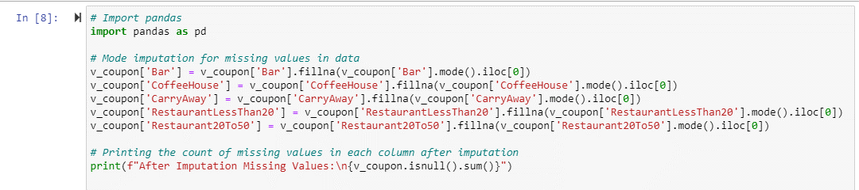

Handle Missing Values:isnull() function checks for the missing values and sum() sums up missing values columnwise.Dropped car column as it has highest number of missing values.
Handle Duplicate values: v_coupon.drop_duplicates() removed duplicate rows from the dataframe.
Mode imputation to handle missing values: Used fillna () method and done mode imputation using mode() function
Checking if the class is balanced or not:
We could see that the classes are partially balanced with 56.7% data in accepted class and 43.2% of data in rejected class.

STATISTICAL ANALYSIS:
Descriptive Statistics:
Summary Statistics:
temperature has_children toCoupon_GEQ5min toCoupon_GEQ15min \
count 12610.000000 12610.000000 12610.0 12610.000000
mean 63.267248 0.414512 1.0 0.559794
std 19.153386 0.492657 0.0 0.496432
min 30.000000 0.000000 1.0 0.000000
25% 55.000000 0.000000 1.0 0.000000
50% 80.000000 0.000000 1.0 1.000000
75% 80.000000 1.000000 1.0 1.000000
max 80.000000 1.000000 1.0 1.000000

toCoupon_GEQ25min direction_same direction_opp Y
count 12610.000000 12610.000000 12610.000000 12610.000000
mean 0.116019 0.215543 0.784457 0.567565
std 0.320260 0.411215 0.411215 0.495434
min 0.000000 0.000000 0.000000 0.000000
25% 0.000000 0.000000 1.000000 0.000000
50% 0.000000 0.000000 1.000000 1.000000
75% 0.000000 0.000000 1.000000 1.000000
max 1.000000 1.000000 1.000000 1.000000

The mean temperature is 63.27F with standard deviation of 19.15F. We could say that the temperature varies around the mean. The minimum temperature is 30F and maximum temperature is 80F.Majority of observations fall in the range of 55-80F.
About 41.45% of observations show the presence of children. This shows that dataset has a major number of individuals with children.
The columns toCoupon_GEQ5min, toCoupon_GEQ15min, toCoupon_GEQ25min have a constant value of 1 which shows that there are no outliers in the data.
About 21.55% of observations have same direction and 78.45 has opposite direction which means that most individuals are travelling in the opposite direction.

Correlation matrix :
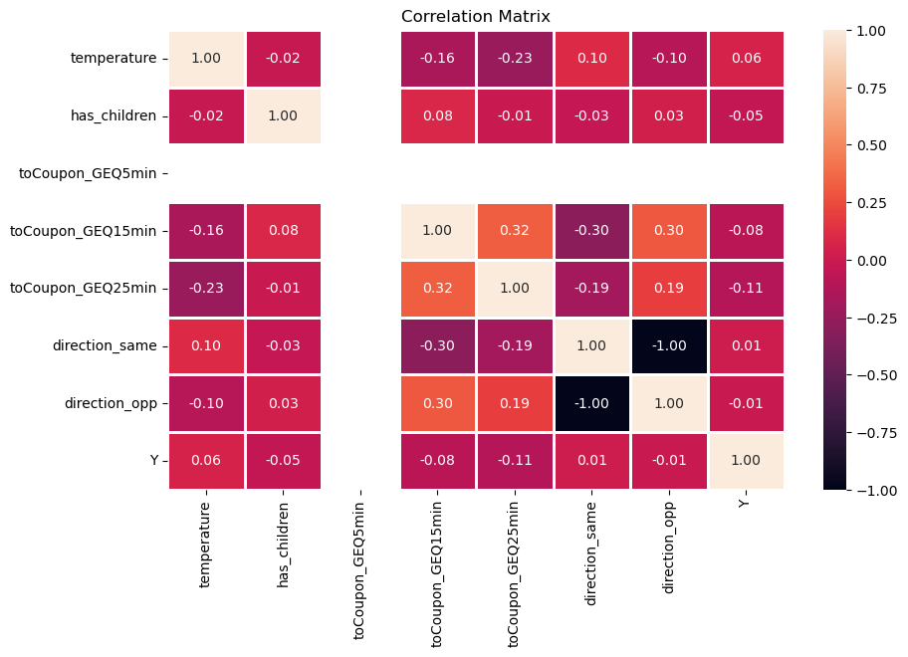

Correlation Analysis:
It is the statistical method used to measure the relationship between two variables. The correlation coefficient indicates the degree to which two variables are linearly related which usually ranges from -1 to 1. The correlation coefficient closer to 1 indicates strong positive correlation (if one variable increases, another variable also increases). The correlation coefficient closer to -1 indicates strong negative correlation (as one variable increases, the other variable decreases). The correlation coefficient close to 0 indicates no relationship between the variables.
From the above figure we could see that toCoupon_GEQ5min does not have any significance with target variable Y. Hence, we can remove that. Direction_same and direction_opp have the same correlation with the target variable. Hence removing one of them.

CHI-SQUARE TEST TO CHOOSE SIGNIFICANT FEATURES:
Chi-Square is used to test independence between each feature in the dataset and the target variable Y to identify the significant features. If the p-value obtained is less than 0.05 shows that the column is associated with the target variable. We selected the top 10 significant features and trained the model.
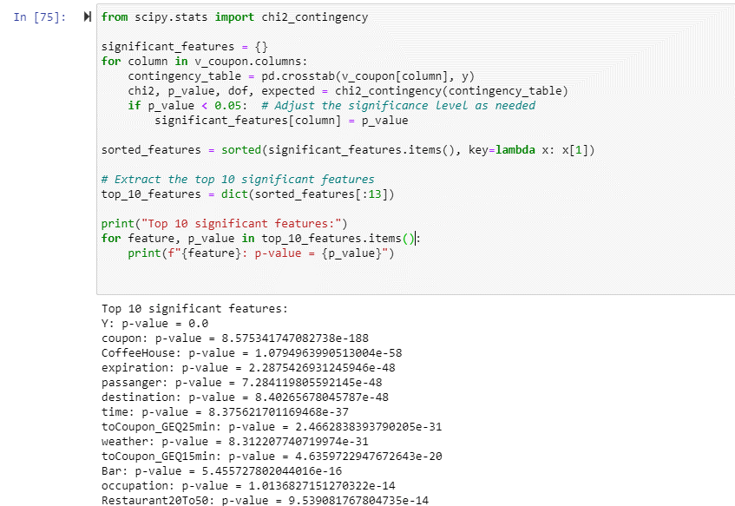

UNIVARIATE ANALYSIS:
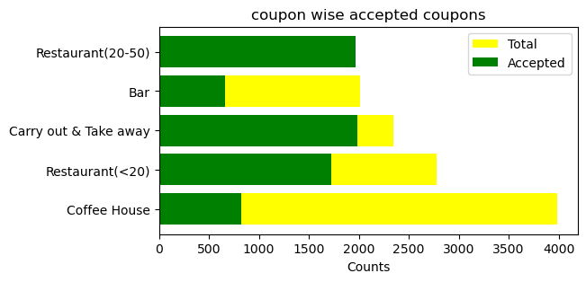
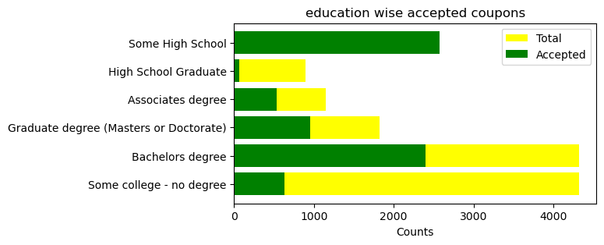

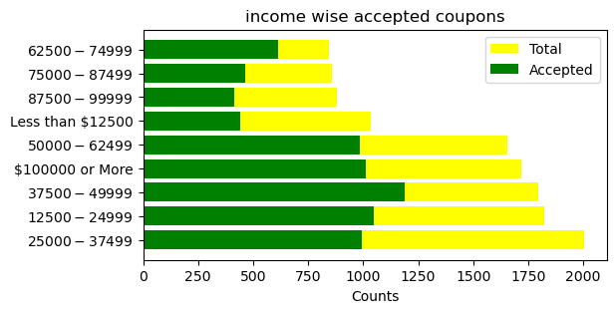

Customers with some high schools have nearly 60% of acceptance rate and those with bachelor’s degrees and graduate degree have similar acceptance of nearly 55%. Whereas high school graduates and no degree students have less acceptance.
Almost every coupon that is between 20-50 worth is accepted. Customers are accepting coupons for high-quality restaurants. There are more rejections among coupons for bars and coffeehouse. People also redeem and carry out coupons more often.
Drivers with 37500-62500, and 1000000 tend to redeem more coupons. Redemption is more among 12500-37500 too.
FEATURE TRANSFORMATION:
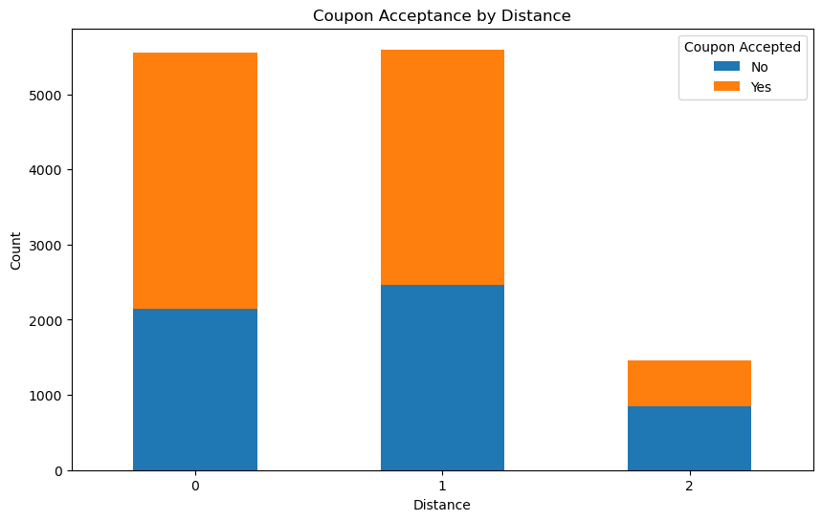

Feature Transformation is the process of converting existing features to new ones or creating new features to better understand the underlying patterns in the data. It uses mathematical or statistical approaches to do this. Some of the feature transformation techniques include.
1.Normalization,
2.Encoding Categorical variables,
3. Feature Engineering,
4. Discretization,
5.Dimensionality Reduction.
Feature Engineering: Created a single distance column using feature engineering. Checked unique values in distance column. Coupons that are less than 15 min driving distance as 0, between 15-25 minutes as 1 and greater than 25 minutes as 2. Dropped unnecessary columns. We could see that Coupons that are less than 15 minutes driving distance are accepted more, than 15-25 minutes. Customers tend to reject coupons that are more than 25 minutes driving distance.
Encoding Categorial Variables:
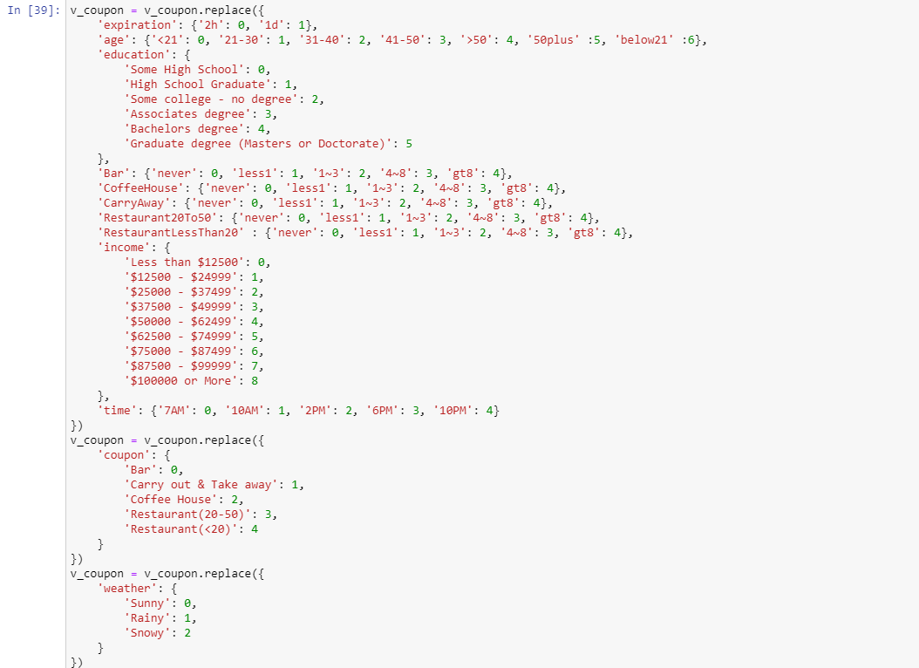

Encoding is done for the variables weather, coupon, Bar, Coffeehouse, Education ,Age ,expiration etc. Above is some related mapping done to make the mathematical and statistical analysis easy.

MULTI-VARIATE ANALYSIS:

TESTING ASSUMPTIONS OF PREDICTIVE MODELS:
- Multicollinearity: Predictor variables should not correlate among themselves and create problems of multicollinearity. It causes instability in estimation of coefficients for the regression model. Small changes in data might cause large changes in the estimated coefficients.
PRINCIPAL COMPONENT ANALYSIS:
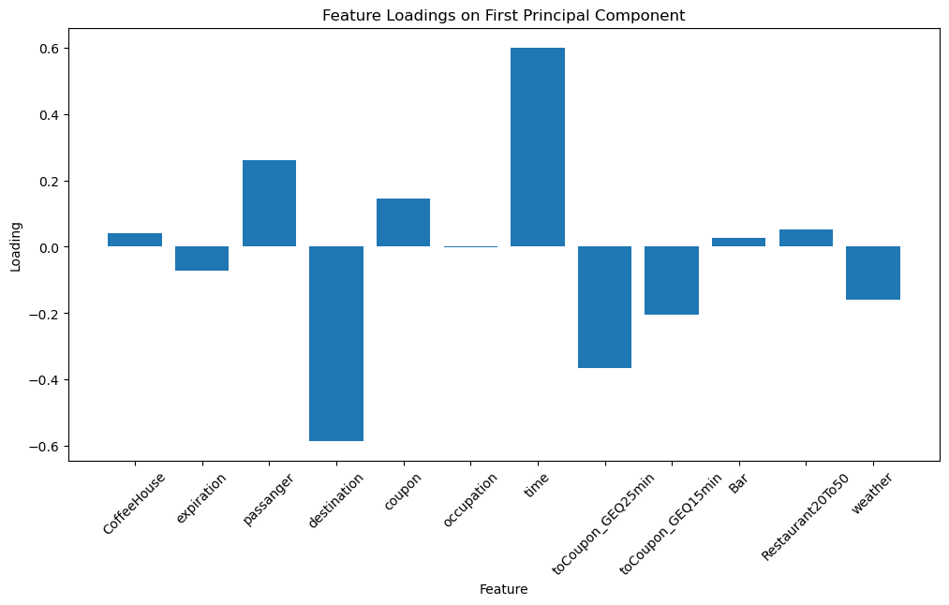
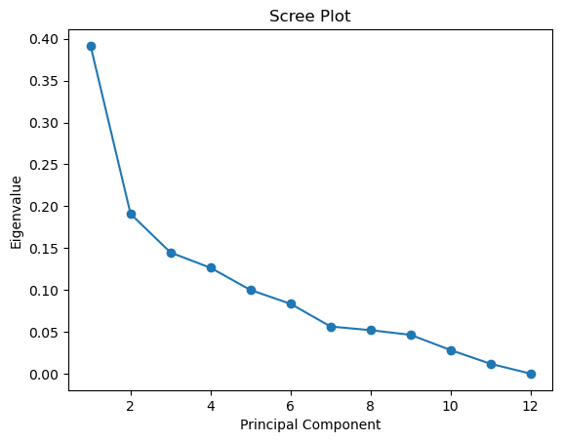

PCA projects the original data to obtain a lower dimensional representation of the data. Eigen value decomposition is one of the methods to perform PCA and to explain variance in the data.
We could see that higher value loadings contribute most to the principal component. Passenger and time contribute most to the principal component. Also, from the eigen value there is at least one component with higher eigen value than other components which states that there is no multicollinearity in the data. Variables are not contributing similarly to the variation in data. Hence, we can interpret the regression coefficients and make predictions on unseen data.

Variable Inflation Factor: It is one of the measures to check multicollinearity. A VIF value greater than 5 indicates the presence of multicollinearity. We could not see any presence of multicollinearity in the dataset.
Variable VIF
0 CoffeeHouse 2.862238
1 expiration 2.232077
2 passanger 1.758192
3 destination 4.848709
4 coupon 3.287715
5 time 4.588249
6 occupation 3.775931
7 toCoupon_GEQ25min 1.446033
8 toCoupon_GEQ15min 2.734085
9 Bar 2.134578
10 Restaurant20To50 3.362851
11 weather 1.330114

- Independent Observations: Our dataset has observations that are independent of each other.
- No extreme Outliers: We do not have any extreme outliers in the dataset.
- Linearity of Dataset: As we could analyze the correlation coefficients and say that there is linear relationship between the predictor variables and Y.
- Big Sample size: Our dataset has enough number of observations and big sample size.

PRELIMINARY RESULTS:
Research question 1:
Frequency Analysis: To identify trends in coupon redemption behavior and analyze the frequency of coupon usage and expiration dates, coupon usage and age.
Univariate Analysis:
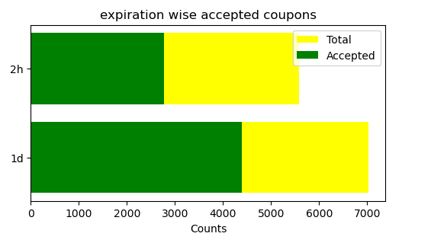
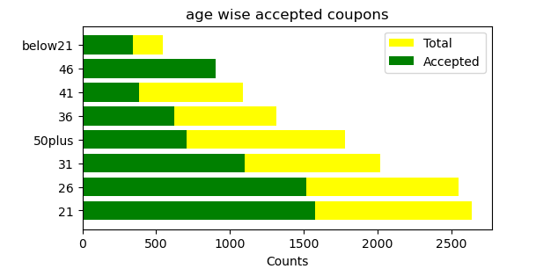

Univariate Analysis is the approach that uses one variable at a time to derive insights. Created a function to perform univariate analysis and find how much percentage of coupons were accepted with expiration time 2h and 1d. How much percentage of coupons were rejected with expiration time 2h and 1d.
Interpretation of Results:
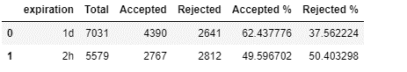
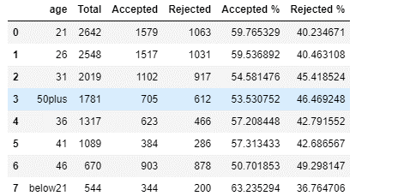

Expiration time 2h: 62.4% ACCEPTED 37.5% REJECTED
Expiration time 1d: 49.5 % ACCEPTED 50.4% REJECTED
The faster the expiration of coupon, the more the redemption of coupon. After one day there are 50-50 chances that a coupon will be redeemed. This is mostly because customers get busy with other works and tend to forget the coupon. It is better to create coupons that have faster expiration in the market. The highest acceptance of coupons is in the age group below 21 and 21-26. Targeted advertising for these age groups brings more profits. There is a 50-50 acceptance rate in the age group of 46 years. We could say that younger age groups are more attracted to the coupon system and tend to spend more money when compared to the middle-aged groups.
Correlation Analysis:
Determine correlation coefficients to investigate the link between coupon usage and expiration dates, also coupon usage and age. Look for any connections between increased coupon utilization and longer expiration periods and age.
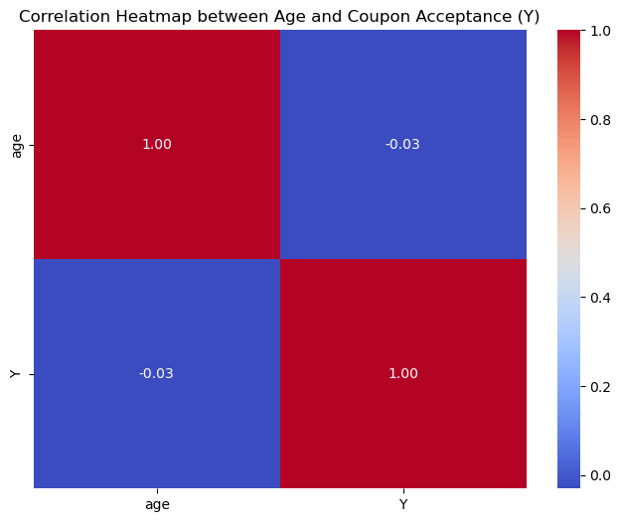
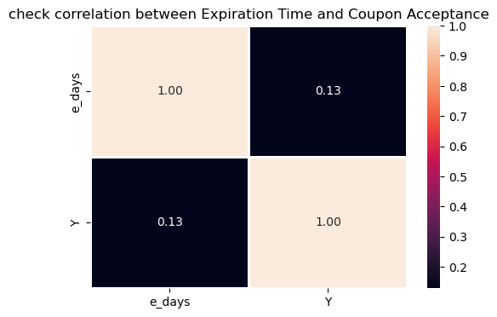

The coefficient of 0.13 signifies that there is a weak positive correlation between the expiration time and coupon acceptance. Increase in expiration time does that increase the coupon acceptance. Coefficient of -0.03 signifies weak correlation. As age increases, coupon acceptance decreases. This goes well with the previous univariate analysis done.
Research question 2:
Which age groups use coupons differently, and what are the unique patterns of coupon redemption behavior that travelers of different ages and different gender follow? Also, plot a histogram for coupon usage for different destinations and time.

Histogram
To make a histogram that illustrates how coupons are used by age groups: For every age group, calculate the frequency of coupon utilization. Plot a histogram with the frequency of coupon utilization on the y-axis and age groups on the x-axis. Examine the histogram to see any patterns or trends in the way that various age groups use coupons.
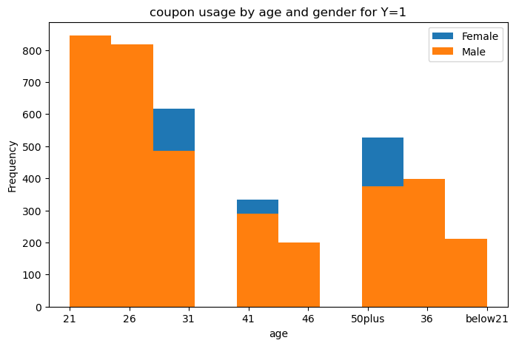
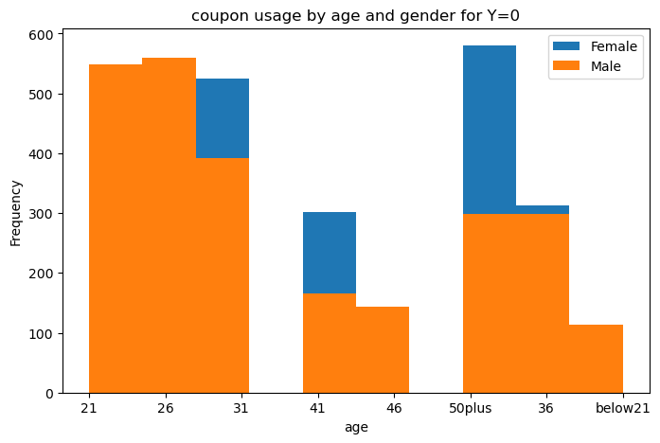

I
Interpretation of Results:
Bivariate analysis involves two variables at a time and identifies the relationship between them and the target variable. Male drivers between age 21-29 and below 21 tend to reject more coupons. Whereas below 21 female drivers mostly don’t reject coupons. Female drivers aged between 50 plus reject more coupons. Also, the highest acceptance Is by the male people for almost every age group. Most acceptance is between 21 and 26 years of male drivers.
Highest number of coupons were accepted by drivers commuting to work at 7AM.The most possible reason is because of the early hours ,customers might not be having enough time to cook lunch or breakfast, there are higher chances of coupon redemption for a early morning cofee and carry out lunch .Next number of coupons were accepted at 10PM and 6PM and destination is home and no urgent place.This is after work most customers tend to return home and redeem coupons for dinner ,and also carry out food for their family .
.
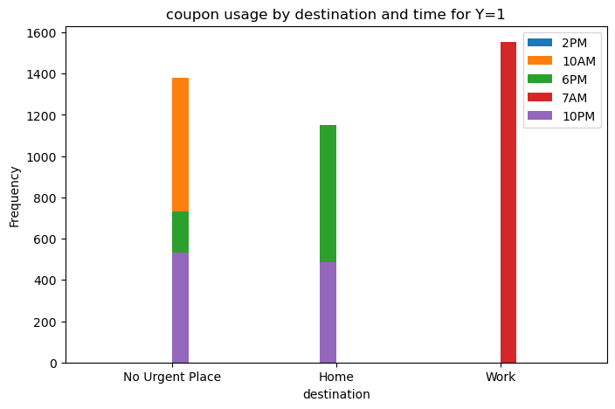

Research question 3:
How do demographic factors (such as age and income, weather) relate to how frequently travelers visit various dining venues (like restaurants, bars, coffee shops)?
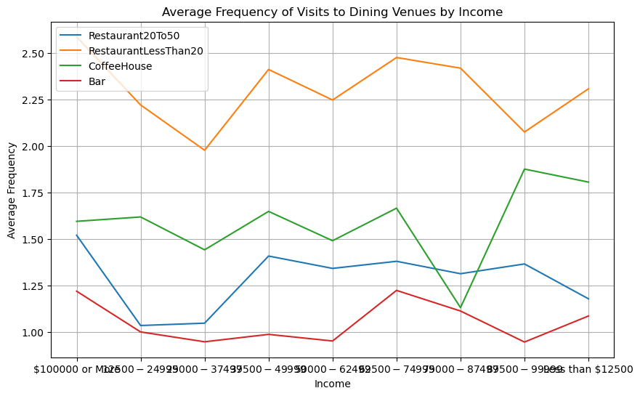

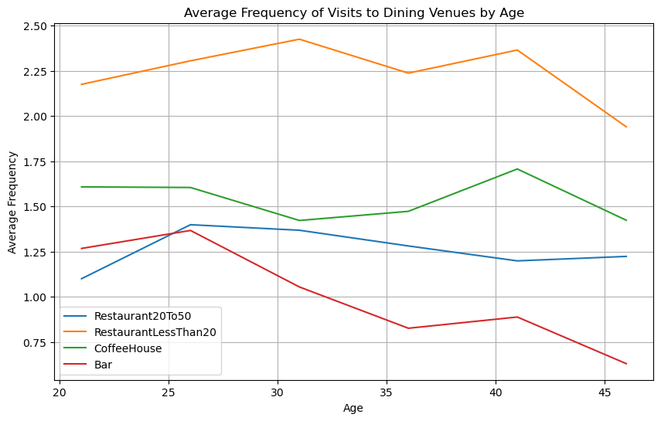
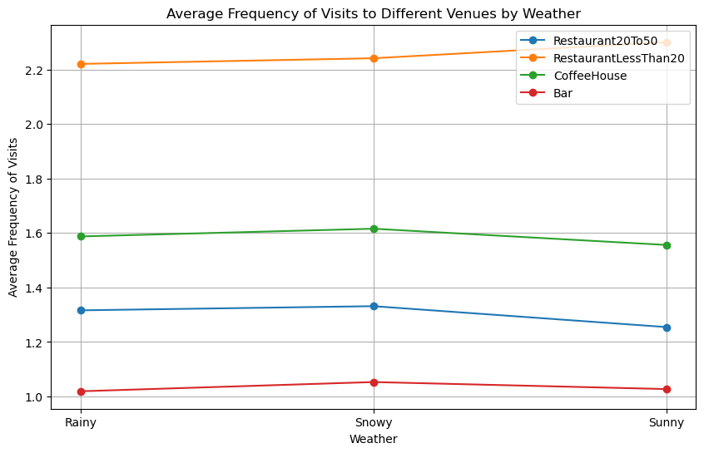

I

Interpretation of Results: More visits are to restaurants that are cheap and affordable irrespective of age, weather, and income. There is an upward trend in the coffee visits which shows that higher income people tend to redeem more coffee coupons. Bars are least preferred by customers when compared to restaurants and coffee houses. It is worth noting that there is a rise in dine-out restaurants. One possible reason might be people getting attracted to fast food restaurants and coffee shops more.
Visits to Coffeehouse are more during stormy and rainy weather when compared to sunny days. People love to drink hot coffee during cold climatic conditions. Cheaper restaurants are visited more during sunny days, Costlier restaurants more during rainy and snowy days. Bars are least visited compared to other establishments irrespective of the climate.
After the age of 41, there is a sudden decline in visits to all establishments. People aged 25-26 visit almost every establishment. Young age people might be on dates or friendly visits.

Acceptance Rate vs Dining Establishments:
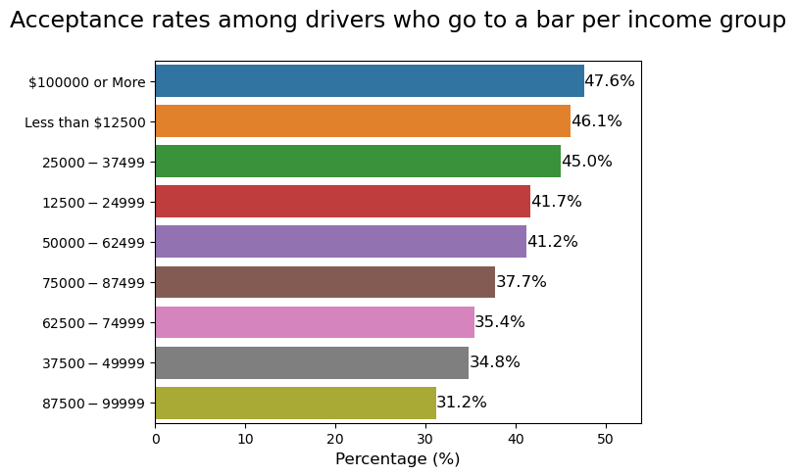
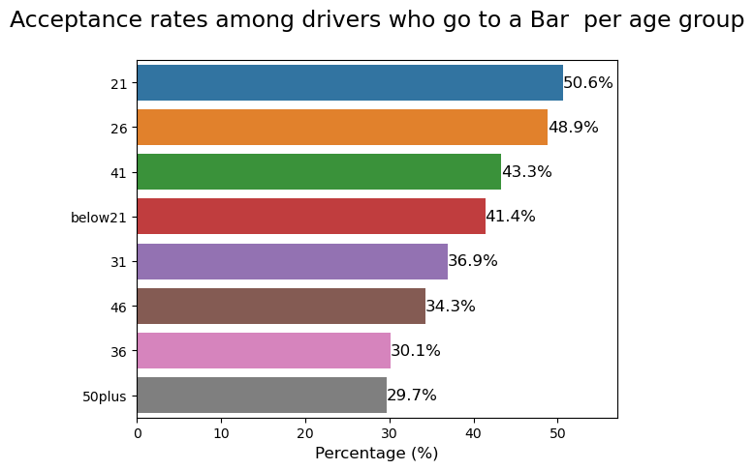

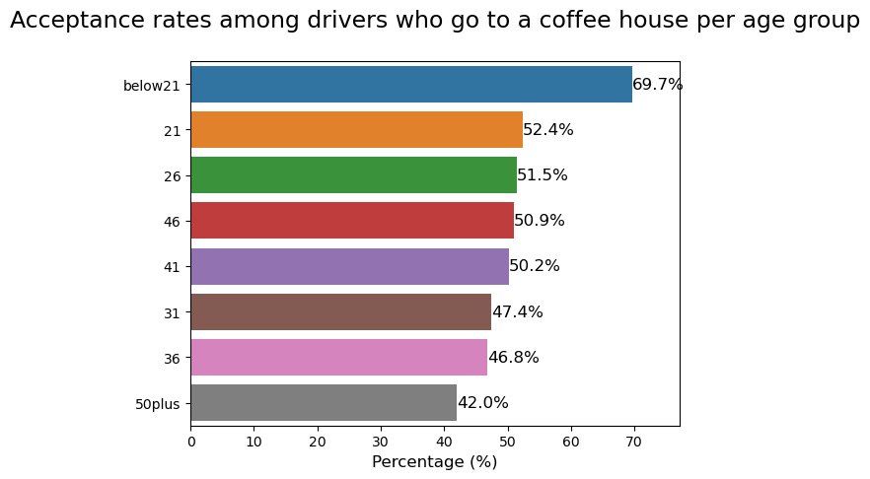
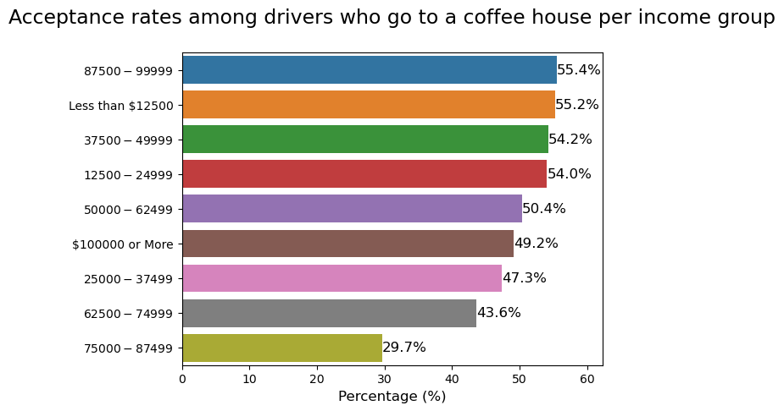

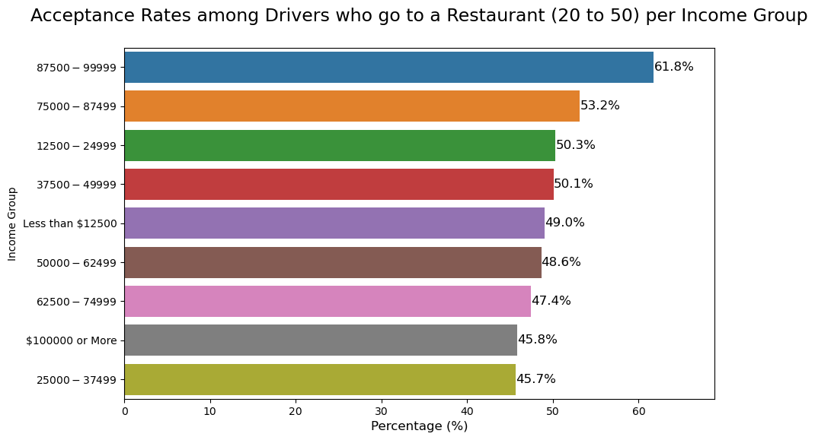
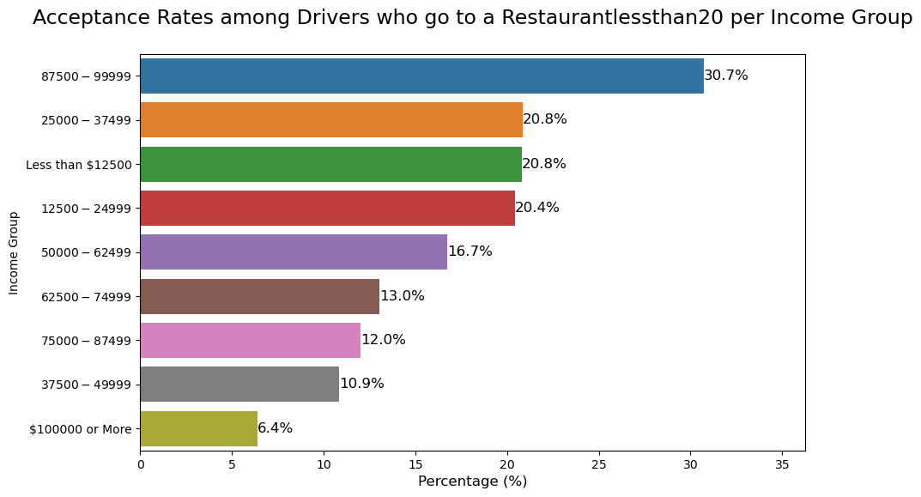

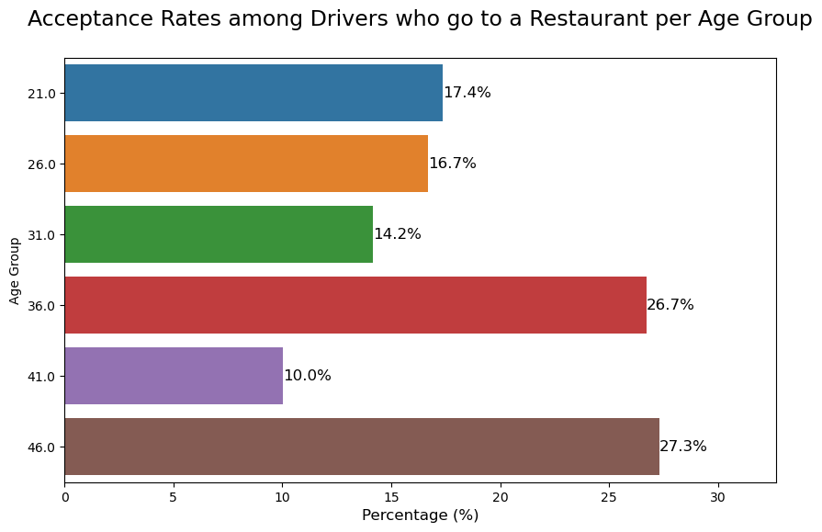

Bars: Highest percentage of bar coupons (50.6%) were accepted by those aged 21 years. The acceptance rate then declines for all other groups until it reaches 29.7% for the age of 50 and above.Higher income drivers accept 47.6% of the bar coupons. People with low income also accept 41-46% of coupons.There is no direct relationship between bar coupons acceptance and income, but young people are likely to redeem more coupons because there might be more partying among young people.
Coffee Houses:
69.7% of the coffeehouse coupons were accepted by drivers aged below 21 years. The acceptance rate then declines for all other groups until it reaches 40% for the age of 50 and above Young people tend to drink more coffee during their commute to schools and colleges.
Restaurants: Drivers with income range 87500-99999 accept most of the restaurant coupons. Also, the age group of 46 accepts more coupons. Middle aged people tend to dine in more with their families.
Research Question 4:
Use logistic regression analysis to predict the probability that a passenger will use a dining coupon based on their demographics (income, age), frequency factors (RestaurantLessThan20, Bar, Coffeehouse, Restaurant20To50) and situational factors (time of the day, coupon expiration time)
Logistic Regression:
Logistic regression is used in cases where we need to estimate the probability of an event occurring given a dataset consisting of independent variables. It is used for classification tasks and predictive analytics where there are finite outcomes. In the case of our dataset, we have coupon acceptance and rejection as outcomes which are finite.
Assumptions of Logistic Regression:
- There must be no multicollinearity between the explanatory variables which we discussed earlier using PCA and VIF.
- Binary nature of the response variable. (Coupon acceptance, Rejection)
- Independent Observations. No extreme outliers.
- Linear relationship between explanatory variables and predictor variables which is evident from the correlation matrix.
- Big Sample size.
Machine Learning Model Workflow:
Model Training
Data Splitting (80:20)
Feature Selection

Model Evaluation
Model Tuning Hyper Parameters

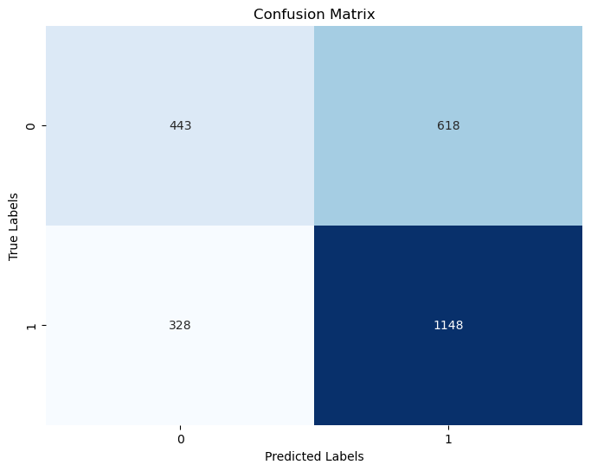
Accuracy: 0.6271186440677966
Confusion Matrix:
[[ 443 618]
[ 328 1148]]
Classification Report:
precision recall f1-score support

0 0.57 0.42 0.48 1061
1 0.65 0.78 0.71 1476

accuracy 0.63 2537
macro avg 0.61 0.60 0.60 2537
weighted avg 0.62 0.63 0.61 2537

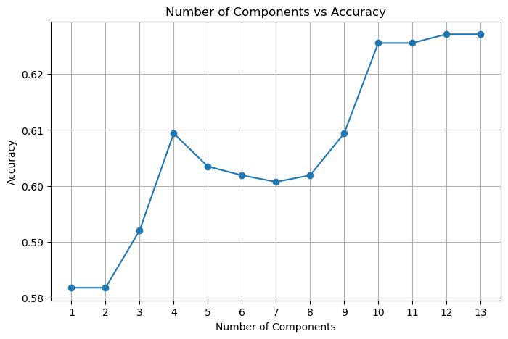
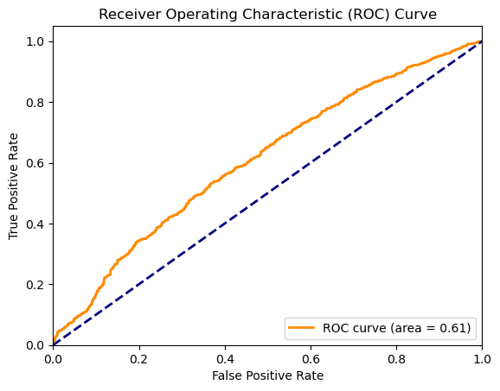

Interpretation:
Initially feature selection is done using chi-square test which is discussed previously. The target variable is selected as Y. Remaining features as X. The data is split into 80% training and 20% testing. The model is fitted using the training data. Model evaluation is done using the test dataset and accuracy is calculated for the model.
To determine the effect of each predictor variable on the chance of utilizing a meal coupon, analyze the logistic regression model's coefficients. Identify the factors that most significantly affect the use of coupons. After the model has been verified and improved, use it to forecast the likelihood that a traveler would utilize a meal voucher based on their demographics, environmental circumstances, time of the day and coupon expiration time, and frequency of dining facility visits.
RESULTS:
Confusion matrix used to calculate the performance of a classification model.It has actual labels and predicted labels.
True Positives (TP):1148 instances where model predicted correct coupon usage(Y=1)
True Negatives (TN):444 instances where model predicted no coupon usage(Y=0)
False Positives (FP):618 instances where model incorrectly predicted Coupon usage where there was none.
False Negatives (FN):328 Instances where model incorrectly predicted no coupon usage where there was one.
Accuracy is 62.71 which indicates that the model correctly predicts the coupon usage for 62.71 percent of instances in the dataset. The receiver Operating curve covers 62% area which indicates the accuracy.
Precision of 0.65 for class 1 means that out of all instances predicted as using a coupon,65% were using a coupon.
Recall of 0.78 for class 1 shows that the model correctly identified 78% of all instances where a coupon was used.
Principal Component Analysis helps to capture the most important patterns in data while reducing
the number of features. Highest accuracy is achieved with nearly 10-13 components.
LOGISTIC REGRESSION COEFFICIENTS AND PREDICTING PROBABILITY:
Positively related features:Using the coefficients of the logistic model ,the positively related features are toCoupon_GEQ15min, Coupon,Passanger.As these values increase possibility of coupon acceptance increases.
Eg: People who travel 15 minutes or more are most likely to accept coupons.
Negatively related features:Bar, Restaurant20To50, toCoupon_GEQ25min,weather.
Eg:Those who prefer bar are less likely to accept the coupons.
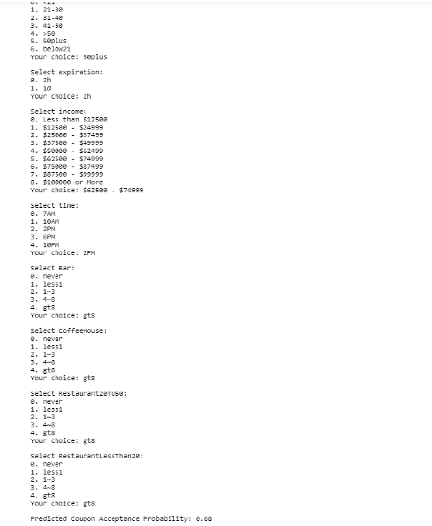
Coefficients of Logistic Regression
Top Features:
toCoupon_GEQ15min: 0.6238559400863803
Bar: -0.38794995535415605
Restaurant20To50: -0.304043284041288
toCoupon_GEQ25min: -0.28747285532423794
passanger: 0.19140853360659882
destination: -0.1434121595636377
occupation: 0.11587678610601002
coupon: 0.08807199788391246
occupation: -0.040398854932904266
expiration: 0.038553481171744765
time: 0.022874033200446762
CoffeeHouse: -0.002009366534469882
weather: -1.1148216914507353e-15

User data is passed to the function logreg.predict_proba which can be used to predict the probability of coupon acceptance
Research Question 5:
Among all the features, which features contribute the most for coupon acceptance? Using these features predict if the coupon can be accepted or not? Also consider coupon as target variable and predict what type of coupon (restaurant, bar, coffeehouse) that can be recommended to the driver using the dataset.
Assumptions:
- Decision trees were chosen as the modeling approach because they can handle numerical and categorical data, offer interpretability, and capture intricate relationships between predictor variables.
- Initially all the training data is chosen as root.
- Then data is distributed recursively based on the attributes. To choose the next node to split, statistical metrics like gini index, Entropy are chosen.
Interpretation: Employing the training dataset, train the decision tree model with coupon acceptance (Y) as the outcome variable. Also train the decision tree model with coupon as the outcome variable to know which coupon can be recommended to the driver using his data. Use all features except Y as predictors. Then split the data int 80% train and 20% test.To learn more about the connections between predictor variables (demographic characteristics, coupon availability) and coupon acceptance for family-friendly eateries or coffee shops, look at the decision tree structure that was produced. Also take random data from users and check if the coupon can be accepted or not. Maximum depth is chosen as 7 and number of leaf nodes is 24 after performing cross validation. Check what type of coupon that can be recommended.
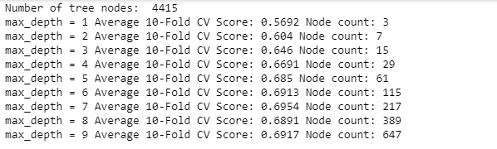
Cross Validation and Hyperparameter Tuning:
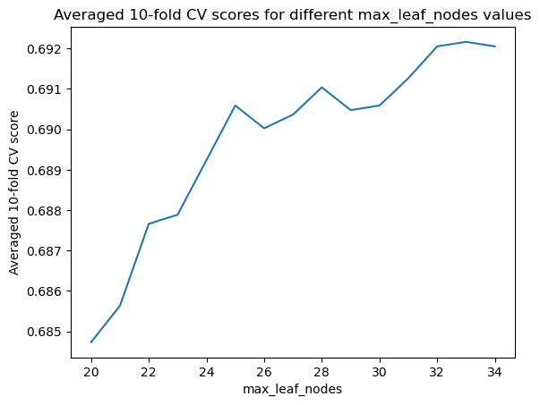
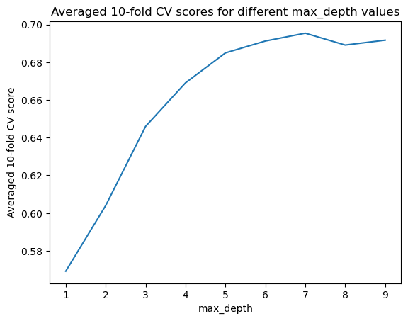

RESULTS:
Achieved an accuracy of 70% with this model with y as target variable. Achieved 79% accuracy to predict coupon type. Features with lower Gini and higher entropy are considered as important features in decision tree. Feature importances can be used in the code to get the top features contributing for the predictions.
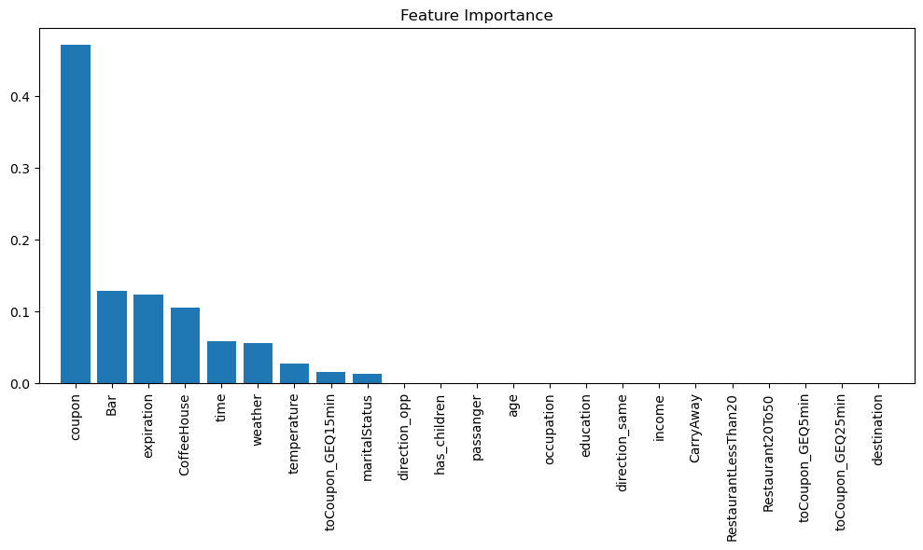
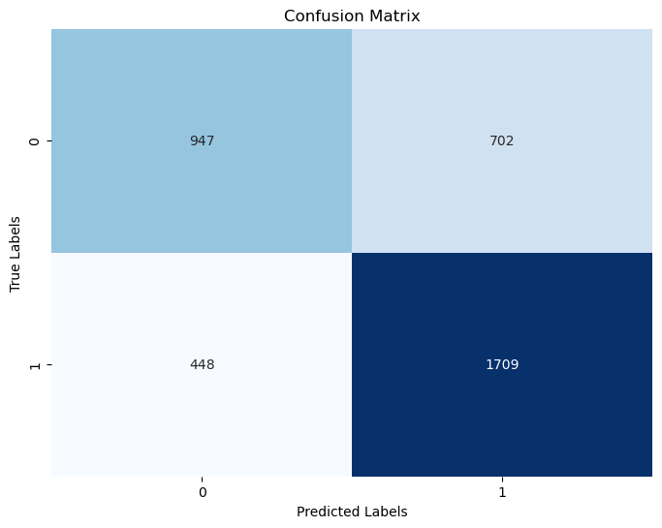

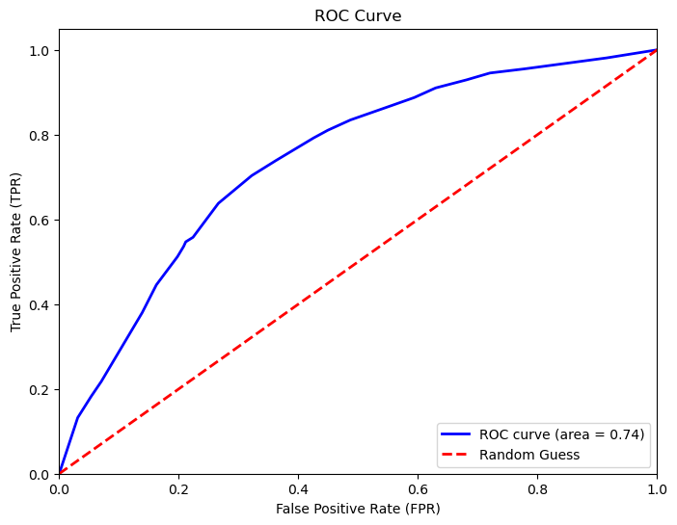

True Positives (TP):1709 instances where model predicted correct coupon usage(Y=1)
True Negatives (TN):448 instances where model predicted no coupon usage(Y=0)
False Positives (FP):702 instances where model incorrectly predicted Coupon usage where there was none.
False Negatives (FN):947 Instances where model incorrectly predicted no coupon usage where there was one.
Accuracy is 74% which indicates that the model correctly predicts the coupon usage for 74% percent of instances in the dataset. The receiver Operating curve which is a plot against false positive rate and true positive rate covers 74% area which indicates the accuracy.

Decision Tree produced:
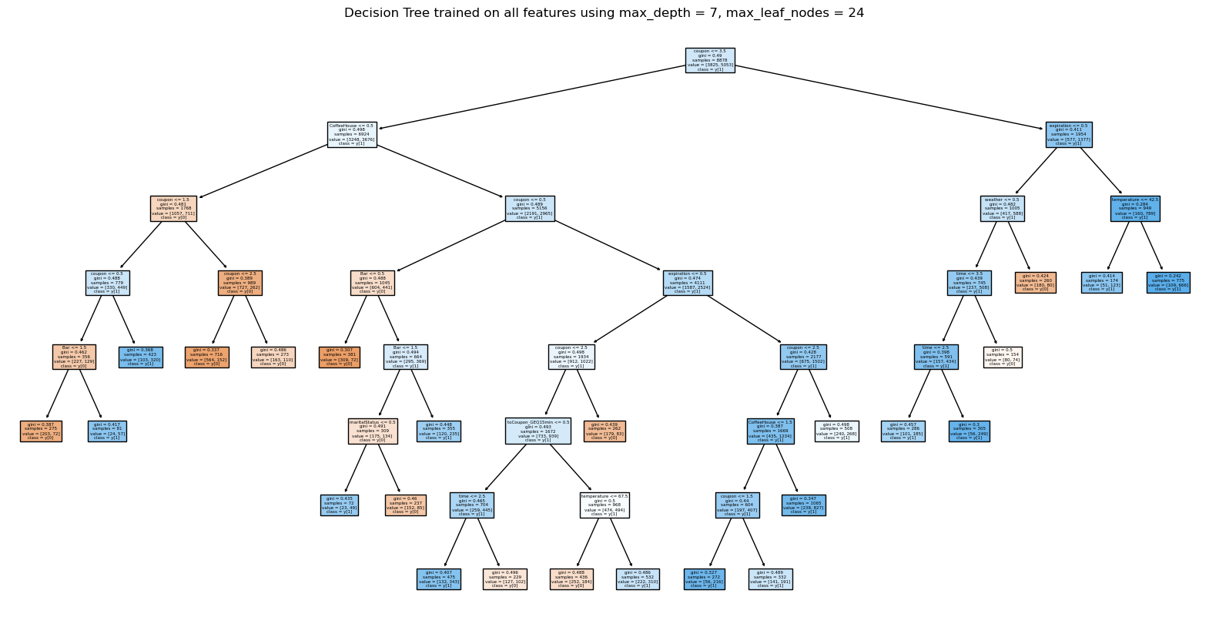
Implementation of model using user data:
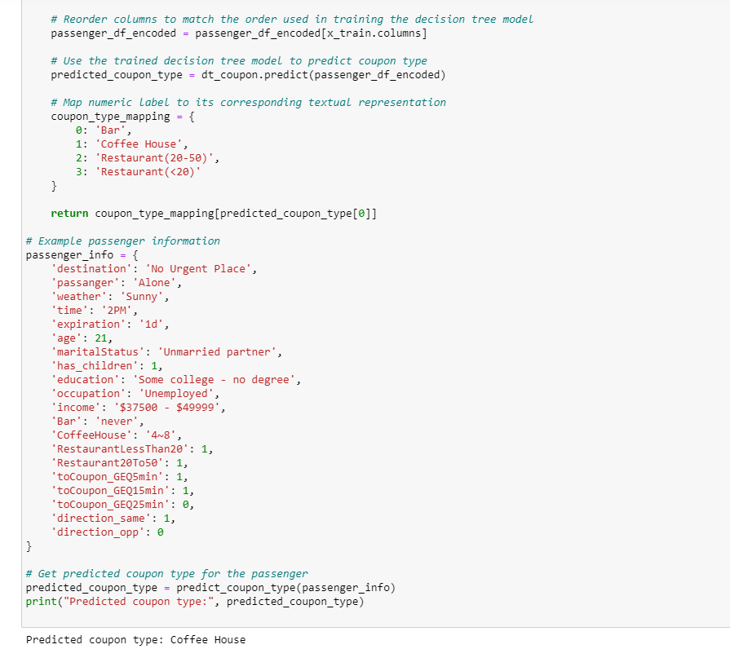
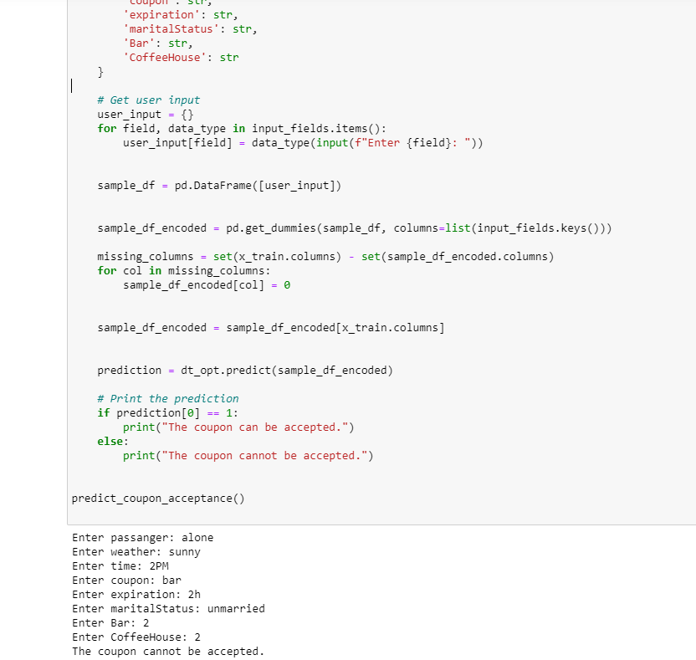

Research Question 6:
Finding Driving Scenarios with High Acceptance Rates: spot patterns and trends in the acceptance rates of coupons in various driving situations.
Clustering:
Clustering is Unsupervised learning technique used to group similar data points based on certain characteristics without any prior knowledge of class labels. Here, the points are assigned to the cluster based on a similarity measure such as Euclidean distance, cosine similarity etc. K-means clustering is one of the clustering approaches that partitions the data into k clusters and iteratively assigns points to the nearest cluster centroid and centroids are updated until convergence. Choosing optimal k value depends on the user and elbow method is one of the techniques. It is well suited for market segmentation. Here in this project, we choose relevant attributes that characterize driving situations, such as the kind of destination, the time of day, the weather, the number of passengers, and the coupon. Select a suitable clustering algorithm, such as hierarchical clustering or k-means clustering.

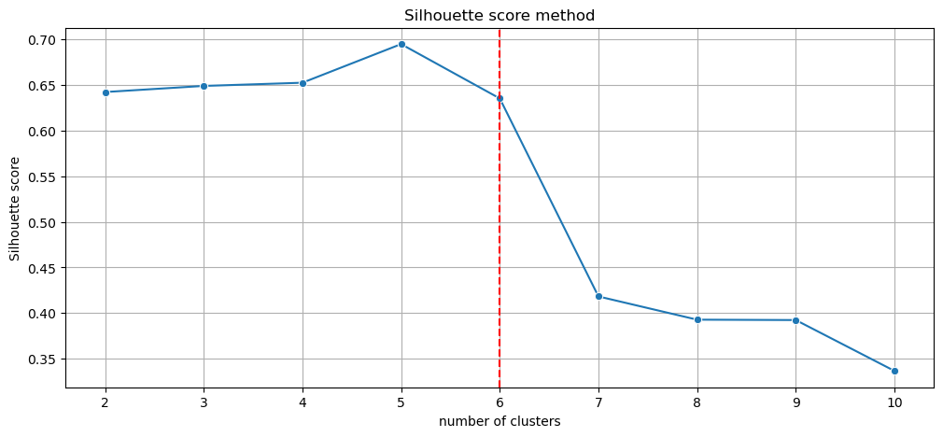
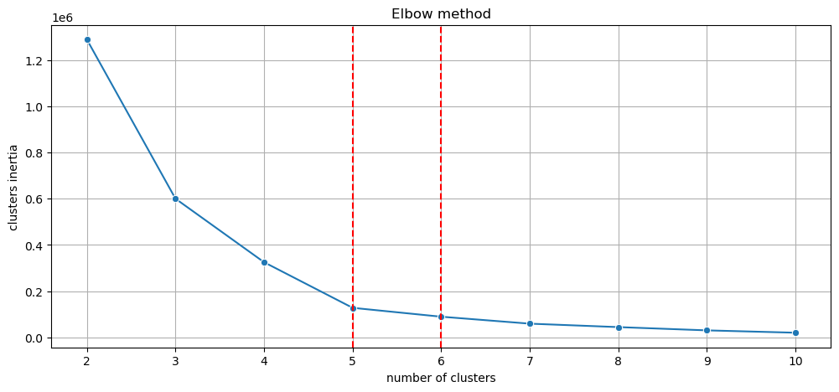

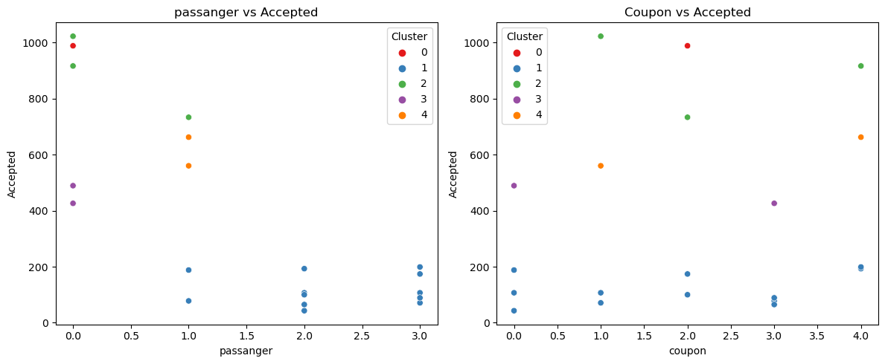
Interpretation of Clusters: PASSENGER VS COUPON:
Examine the resultant groups to determine the traits that driving situations in each cluster have in common. In this stage, the values of the attributes a contributed to the clustering are interpreted by looking at the centroids, or representative points, of each cluster.
Cluster Inertia: It is within cluster sum of squares or cluster variance that shows how internally the points in the cluster are close to the centroids. Select the value of k that minimizes the inertia while not overfitting. Look at the elbow point where there is a drop in the inertia and later it becomes marginal.
The silhouette score method is used to measure the quality of clusters that are produced after k means clustering. A score closer to 1 show that the clusters are well separated and close to the members of their own clusters. A negative score indicates that our members are wrongly assigned to another cluster.
From the figure we could see that inertia is low at k=5 and silhouette score is maximum at k=5.So the optimal k chosen is 5.
Analysis: Passanger 0-alone 1.0-friends 2.0- kids 3.0- partner
Coupon: 0- bar ,1-carryout, 2-coffeehouse, 3-restaurant <20 ,4- restaurant20To50.
We could see that coupons are mostly redeemed when travelling with kids and partner. There is acceptance for all types of coupons but mostly Coupons for restaurants (<20) are preferred. It means that people with families prefer budget friendly restaurants to dine in. Also, there are more fast food centers and small eateries, ice-cream shops that cost <20.It is beneficial for these businesses to implement coupon system to boost their business.
WEATHER VS COUPON:

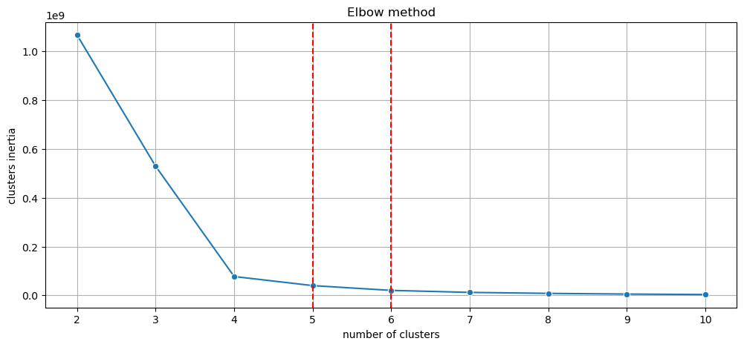

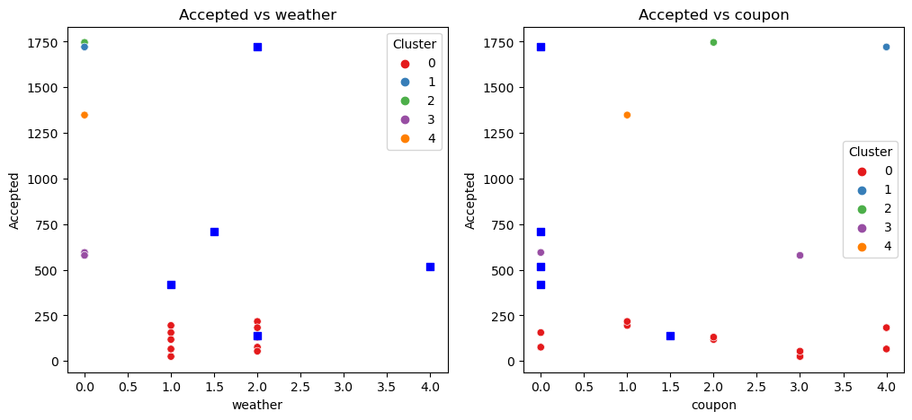
Analysis:
Weather-0: Sunny ,1: Rainy ,2: Snowy
Most coupons are accepted during rainy and snowy reasons and mostly they are for carryout, coffeehouse, and restaurant (<20) coupons. During stormy weather people tend to drink hot coffee and eat fast food. Few people prefer to carry out while travelling.
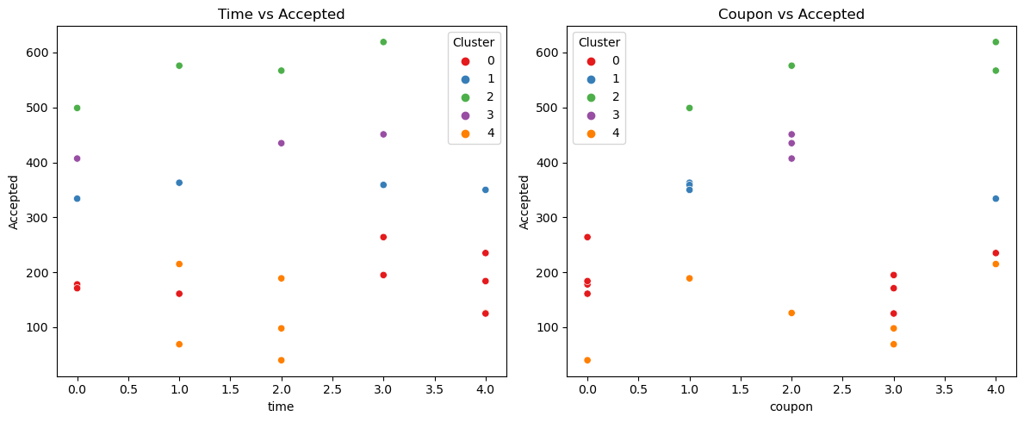
Analysis:
Time: {'7AM': 0, '10AM': 1, '2PM': 2, '6PM': 3, '10PM': 4}
Coupons for restaurants are redeemed mostly during afternoons around 2PM.We could say that people tend to use restaurant coupons for their lunch. There are bar coupons redeemed during late nights and early hours. It is good that coupons circulate in the early hours so that the customers make maximum use of the coupon during the rest of the day.
Other Models Performed:
XG BOOST :72.4%
Best Parameters: {'max_depth': 4, 'objective': 'binary:logistic', 'eval_metric': 'logloss','verbosity': 0}
SVM :72.6%
Best Parameters: {'C': 10, 'gamma': 0.1, 'kernel': 'rbf'}

Software and Tools: Selecting the appropriate software and tools for analysis is crucial. Numerous tools for data analysis and modeling are available with statistical software programs like Python that include libraries like pandas, sci-kit-learn, or TensorFlow. We are using Python for this project. If we are going to further deploy the application, we are going to use the Google Cloud Platform.
Ethical Considerations: Throughout the project, ethical issues like fairness should be addressed. It is crucial to make sure that data is used responsibly and to consider how the analysis may affect certain people or communities.
Conclusion:
Recommendations:
- We can keep the learned logistic regression model to use in a real-world scenario as a practical application or decision-making system where it can be used to make predictions on new data. Businesses can Integrate the models into mobile as an application or reservation systems to provide personalized recommendations to travelers regarding the coupons based on their profile and circumstances.
- Give companies in the food and beverage sector information on successful marketing tactics and promotions that are suited to demographic groups by offering insights into customer behavior and preferences using the decision tree produced.
- MARKETING CAMPAIGNS: Plan targeted advertising during specific time and weather conditions where the coupons are most redeemed. Clustering is used to show that coupons for restaurants are preferred for afternoon travels, while coupons for coffee shops are more likely to be accepted for morning commutes, coupons for bars during night commutes.
- DYNAMIC PRICING AND INVENTORY MANAGEMENT: Generate only the required number of coupons by predicting the demand using the models and plan pricing schemes that bring profits.
- REWARDS: Filter users who mostly use coupons and provide them with more rewards and discounts to increase loyalty.
- MULTI CHANNEL INTEGRATION: Also integrate with social media platforms, Maps to provide the best experience with ease. Include an icon that shows the nearest places to redeem the coupon.
- Also, the coupons can be integrated with various businesses like uber eats, door dash, Grubhub etc.
HOW OUR PROJECT IS DIFFERENT FROM OTHER EXISTING RECOMMENDATION SYSTEMS?
We can accurately predict coupon redemption for an individual. Unlike generic models that concentrate on history only, we can also provide personalized services to each customer based on his/her driving conditions and economic status. Our model is scalable and flexible and can work very well with huge datasets and growing market conditions.
Coupons help people to have a rewarding experience and boost the revenue of companies. We gain customer loyalty by developing and improving the recommendation systems in the market. This subject must be given importance by the companies to remain balanced in this competitive market.
Users and businesses must not only consider their preferences but also explore the recommendation systems so that they can achieve more success. Not only the accuracy of the models must be considered, but we should also consider how these models bring success and profits to the businesses. The models must also be chosen and modified according to the market trends.
Future Improvements:
We also can implement Cat boost and check how it performs when compared to the above models. As mentioned in Hancock & Khoshgoftaar (2020) we need to check its superiority over other learners. We can also implement k-medoids as it chooses actual data points as centroids and dissimilarity measures. They can be more robust to outliers and noise.
References:
Mei, H., & Li, X. (2019). Research on E-commerce Coupon User Behavior Prediction Technology Based on Decision Tree Algorithm. International Core Journal of Engineering, 5(9), 48-58. https://doi.org/10.6919/ICJE.201908_5(9).0008
Langen, H., & Huber, M. (2023). How causal machine learning can leverage marketing strategies: Assessing and improving the performance of a coupon campaign. PLoS One, 18(1). https://doi.org/10.1371/journal.pone.0278937
Wang, T., Rudin, C., Velez, F. D., Liu, Y., Klampfl, E., & MacNeille, P. (2017). A Bayesian framework for learning rule sets for interpretable classification. Journal of Machine Learning Research, 18(1), 2357–2393. https://jmlr.org/papers/v18/16-003.html

Martens, D., Vanthienen, J., Verbeke, W., & Baesens, B. (2011). Performance of Classification Models from a User Perspective. Decision Support Systems, 51(4), 782-793. https://doi.org/10.1016/j.dss.2011.01.013
Atiq, R., Fariha, F., Mahmud, M., Yeamin, S. S., Rushee, K. I., & Rahim, S. (2022). A Comparison of Missing Value Imputation Techniques on Coupon Acceptance Prediction. International Journal of Information Technology and Computer Science, 14(5), 15. https://doi.org/10.5815/ijitcs.2022.05.02
Buckinx, W., Moons, E., Van den Poel, D., & Wets, G. (2004). Customer-adapted coupon targeting using feature selection. Expert Systems with Applications,26(4), 509–518. https://doi.org/10.1016/j.eswa.2003.10.009
Asllani, A. (2014). Business Analytics with Management Science Models and Methods. Pearson. https://ptgmedia.pearsoncmg.com/images/9780133760354/samplepages/9780133760354.pdf
Pedregosa, F., Varoquaux, G., Gramfort, A., Michel, V., Thirion, B., Grisel, O., Blondel, M., Müller, A., Nothman, J., Louppe, G., Prettenhofer, P., Weiss, R., Dubourg, V., Vanderplas, J., Passos, A., Cournapeau, D., Brucher, M., Perrot, M., & Duchesnay, É. (2011). Scikit-learn: Machine Learning in Python. Journal of Machine Learning Research, 12(85), 2825–2830.
Depari, G. S., Shu, E., Fachriza, C. A., Chow, J., Wijaya, J., Winata, R. (2022). CUSTOMERS’ RESPONSES TOWARDS IN-VEHICLE COUPON RECOMMENDATION AN IMPLEMENTATION OF THE BUSINESS ANALYTICS CONCEPT. Jurnal Ekonomi,11(02), 1157–1167. https://ejournal.seaninstitute.or.id/index.php/Ekonomi/article/view/506

Liu, C. J., Huang, T. S., Ho, P. T., Huang, J. C., Hsieh, C. T. (2020). Machine learning-based e-commerce platform repurchase customer prediction model. PLOS ONE, 15(12), e0243105. https://doi.org/10.1371/journal.pone.0243105
Patil, Y., Pawar, O., Ingle, R. (2019). Coupon Purchase Prediction using Machine Learning. International Journal for Scientific Research and Development,7(2),1232–1234. https://ijsrd.com/Article.php?manuscript=IJSRDV7I21146
Plummer, M. (2020, October 8). Five Ways Coupons Can Help Your Business Attract Loyal Customers. Forbes.
https://www.forbes.com/sites/forbestechcouncil/2020/10/08/five-ways-coupons-can-help-your-business-attract-loyal-customers/?sh=473b8b181bc0
Yang, B. (2022) Clothing Design Style Recommendation Using Decision Tree Algorithm Combined with Deep Learning, Computational Intelligence and Neuroscience,2022(5745457). https://doi.org/10.1155/2022/5745457
Chen, R.C., Huang, C., & Ting, Y. (2017). A Chronic Disease Diet Recommendation System Based on Domain Ontology and Decision Tree. J. Adv. Comput. Intell. Intell. Informatics, 21, 474-482.
Alghamdi, A. (2023). A Hybrid Method for Customer Segmentation in Saudi Arabia Restaurants Using Clustering, Neural Networks and Optimization Learning Techniques. Arab J Sci Eng, 48(2), 2021–2039. https://doi.org/10.1007/s13369-022-07091-y
Bujisic, M., Bogicevic, V., Parsa, H. G., Jovanovic, V., & Sukhu, A. (2019). It’s Raining Complaints! How Weather Factors Drive Consumer Comments and Word-of-Mouth.
Journal of Hospitality & Tourism Research, 43(5), 656-681.
https://doi.org/10.1177/1096348019835600

Pawlicka, A., Pawlicki, M., Kozik, R., Choras, R. S. (2021). A Systematic Review of Recommender Systems and Their Applications in Cybersecurity. Sensors (Basel),21(15),5248. https://doi.org/10.3390/s21155248
Acilar, A. M., & Arslan, A. (2009). A collaborative filtering method based on artificial immune network. Expert Systems with Applications, 36(4), 8324-8332.
Chen, L.S., Hsu, F.H., Chen, M.C., & Hsu, Y.C. (2008). Developing recommender systems with the consideration of product profitability for sellers. Information Sciences,178(4), 1032–1048. https://doi.org/10.1016/j.ins.2007.09.027
Jalali, M., Mustapha, N., Sulaiman, N., Mamat, A. (2010). WebPUM: A Web-based recommendation system to predict user future movements. Expert Systems with Applications, 37(9), 6201–6212. https://doi.org/10.1016/j.eswa.2010.02.105
Isinkaye, F. O., Folajimi, Y. O., Ojokoh, B. A. (2015). Recommendation systems: Principles, methods, and evaluation. Egyptian Informatics Journal/Egyptian Informatics Journal,16(3), 261–273. https://doi.org/10.1016/j.eij.2015.06.005
Lee, J., Hyun, Y., Yun, Y., Lee, J., Lee, J. S., Park, G. L. (2017).DESIGN OF A GENETIC ALGORITHM-BASED COUPON ADVERTISEMENT FOR ELECTRIC VEHICLES. International Journal of Advances in Electronics and Computer Science,4(1),2394-2835.
Beregovskaya, I., & Koroteev, M. (2021). Review of Clustering-Based Recommender Systems. arXiv preprint arXiv:2109.12839.
Wasid, M., & Ali, R. (2018). An Improved Recommender System based on Multi-criteria Clustering Approach. Procedia Computer Science,131, 93–101. https://doi.org/10.1016/j.procs.2018.04.190
Hancock, J.T., Khoshgoftaar, T.M. (2020). Cat Boost for big data: an interdisciplinary review. Journal of Big Data, 7(94). https://doi.org/10.1186/s40537-020-00369-8
in-vehicle coupon recommendation. (2020). UCI Machine Learning Repository. https://doi.org/10.24432/C5GS4P

